How To Start Ecommerce

*Vivek Biradar*

*dept of Information Technology (of Affiliation)*

*Shah and Anchor Kutchhi College of Engineering*

*(of Affiliation)*

Mumbai,India vivek.biradar16591[@sakec.ac.in](mailto:sameer.marathe16536@sakec.ac.in)

***Abstract*—***The knapsack problem is a classic combinatorial optimization challenge with numerous practical applications in diverse fields such as finance, logistics, and resource allocation. In its basic form, the problem involves selecting a subset of items from a given set, each with a specific weight and value, to maximize the total value while staying within a limited capacity constraint. This abstract provides a concise overview of the knapsack problem, its variants, and various solution approaches, including dynamic programming, greedy algorithms, and metaheuristic methods. It highlights the NP-hard nature of the problem and the ongoing research efforts to develop efficient algorithms and heuristics to tackle real-world instances. Understanding and solving the knapsack problem is crucial for optimizing decision-making processes in various domains and continues to be a subject of active research and development.*

***Keywords—Knapsack Problem,Combinatorial Optimization Resource Allocation,Dynamic Programming, NP-Hard***

**I. INTRODUCTION**

## The knapsack problem is a fundamental and widely studied problem in combinatorial optimization. It is a classic example of a problem that arises in resource allocation, decision-making, and planning scenarios across various domains. In essence, the knapsack problem can be framed as follows: Imagine you have a knapsack with a limited carrying capacity, and you are presented with a set of items, each having a specific weight and value. Your objective is to determine the optimal selection of items to include in your knapsack, maximizing the total value of the items while ensuring that the combined weight does not exceed the knapsack's capacity.

This problem can be found in everyday situations. For instance, a traveler packing their bag for a trip must decide which items to bring while considering weight restrictions imposed by airlines or personal preferences. Similarly, a financial investor seeks to maximize their portfolio's return while adhering to investment limits and risk constraints. In logistics, efficient cargo loading in trucks or containers relies on solving a variation of the knapsack problem to make the best use of available space and resources.

# Definition

## The knapsack problem is an optimization problem in which you must select items with specific weights and values to maximize the total value, subject to a constraint on the total weight not exceeding a specified limit.

Given a set of N items numbered from 1 up to N, each with a weight Wi and a value Vi

, along with a maximum weight capacity M,

Maximize:

𝑉𝑖𝑋𝑖

𝑁

𝑖=1

Subject to:

𝑊𝑖𝑋𝑖 ≤ 𝑀,

𝑁

𝑖=1

𝑋𝑖 ∈ {0,1}.

Here Xi

represents the number of instances of item i to include

in the knapsack. Informally, the problem is to maximize the sum of the values of the items in the knapsack so that the sum of the weights is less than or equal to the knapsack's capacity.

**2. Methodology**

### Data Collection

Explain how you collected the data or information for your study. This section should include details on:

Data Sources: Describe the sources of data, such as experiments, surveys, simulations, or existing datasets.

Data Collection Instruments: Specify the tools or instruments used for data collection, including any software, hardware, or survey forms.

Data Acquisition Process: Describe the steps taken to gather the data, including the sampling process and data recording.

Data Preprocessing: Explain any data preprocessing steps, such as data cleaning, filtering, or transformation, if applicable.

1. **Experimental Setup** (if applicable)

If your research involves experiments or simulations, provide information about the setup and conditions. Include details on:

Experimental Environment: Describe the hardware and software environment used for experiments or simulations.

Experimental Design: Explain the design of your experiments, including factors, levels, and variables.

Control Variables: If relevant, discuss the variables that were controlled or held constant during experiments.

### Data Analysis

Detail the methods and tools you used to analyze the data. This section should include:

Statistical Techniques: Explain any statistical methods, algorithms, or models used for data analysis.

Software Tools: Mention the software or programming languages (e.g., MATLAB, Python, R) used for data analysis.

Evaluation Metrics: Define the metrics used to measure the performance or results of your study.

### Ethical Considerations

Address any ethical considerations and measures taken to ensure the ethical conduct of your research. This may include:

Informed Consent: Describe how informed consent was obtained from participants if human subjects were involved.

Confidentiality: Explain how participant data and identities were protected.

Ethical Approvals: If applicable, provide information about ethical approvals from relevant institutional review boards.

### Validation and Reliability

Explain how you ensured the validity and reliability of your research findings. This may include:

Validation Procedures: Describe how you validated the results through experiments, cross-validation, or other methods.

Reliability Measures: Discuss any measures taken to ensure the reliability of data and results.

### Limitations

Acknowledge any limitations or constraints that may have affected your methodology or the study's results.

# 3 Analysis

## A 1998 study of the Stony Brook University Algorithm Repository showed that, out of 75 algorithmic problems, the knapsack problem was the 18th most popular and the 4th most needed after kd-trees , suffix trees , and the bin packing problem[12]. Aspects such as the capacity and the number of items of the knapsack play a vital role in the computation of the number of basic operations and the total memory consumed by the algorithms used. Hence, the analysis of the above algorithms have been made by varying the number of inputs and the capacity of the knapsack. First, the No. of computations, i.e. the number of basic operations in the algorithms have been computed. Then, the total memory consumed by the data structures used in the algorithms have been computed. The results are presented below

### Problem Complexity:

The knapsack problem is classified as NP-hard, which means that finding an optimal solution for larger instances becomes computationally infeasible with existing algorithms. As the number of items and the knapsack's capacity increase, the problem's complexity grows exponentially. This complexity underscores the importance of developing efficient algorithms and heuristics to solve it.

Variants and Real-World Applications:

The knapsack problem has multiple variants, such as the 0/1 knapsack problem, fractional knapsack problem, and multiple knapsack problem, each tailored to specific scenarios. Real-world applications include resource allocation, financial portfolio optimization, cargo loading, project scheduling, and more. Understanding these variations is vital for addressing practical

challenges.

Solution Approaches:

Several approaches have been developed to tackle the knapsack problem:

* 1. **Dynamic Programming**: This technique is suitable for smaller instances and guarantees an optimal solution. However, it has limitations in handling larger problems due to its high time complexity.
  2. **Greedy Algorithms:** Greedy algorithms provide approximate solutions quickly but may not always find the optimal solution.

Metaheuristic Methods: Techniques like genetic algorithms, simulated annealing, and particle swarm optimization are employed to find good solutions for large instances. While they may not guarantee optimality, they are valuable for complex real-world applications.

### Practical Significance:

The knapsack problem's practical significance cannot be overstated. It plays a crucial role in optimizing resource allocation, financial decision-making, and supply chain management. For instance, in the finance sector, it assists in constructing investment portfolios that maximize returns while adhering to risk constraints. In logistics, it optimizes cargo loading to make efficient use of limited space and resources.

### Future Directions:

Ongoing research in the field continues to focus on developing more efficient algorithms and heuristics, improving the handling of uncertainties, and addressing variants that account for dynamic and changing parameters. As technology evolves, the applicability of the knapsack problem to real-world scenarios is expanding, making it an area ripe for further investigation.

# No. of computations

The analysis of the number of computations is done by generating the number of basic operations made by the algorithms by varying the number of items, and using random values for the profit and weight of each item included. The capacity of the knapsack is kept constant at each case. The results obtained are tabulated and are presented below:

* + 1. Varying the number of Items and having fixed Capacity = 10

### Table. 1

|  |  |  |  |
| --- | --- | --- | --- |
| No. of items | Greedy | Branch & Bound | Dynamic |
| 10 | 22 | 28 | 73 |
| 25 | 65 | 77 | 168 |
| 50 | 110 | 168 | 329 |
| 100 | 235 | 253 | 623 |
| 200 | 538 | 1057 | 1279 |
| 300 | 835 | 2993 | 1899 |
| 500 | 1545 | 5012 | 3192 |

Table. 1 suggests that the number of computations of the three techniques increase with different rates with the increase in the number of items.

The graph of Table. 1 is plotted below, with the No. of items on the X-axis and the No. of computations on the Y-axis:

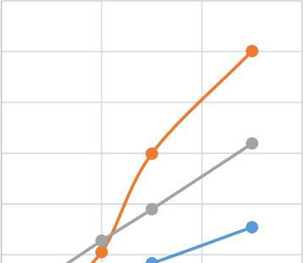

This demonstrates the time complexity of the latter two techniques, which are independent of the capacity of the knapsack.

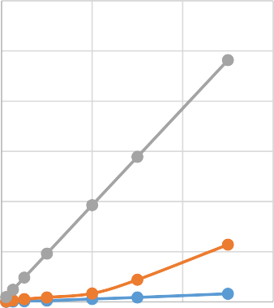The graph of Table. 2 is plotted below, with the No. of items on the X-axis and the No. of computations on the Y-axis:

### Graph. 1

The above graph shows that the Branch & Bound technique has a non-linear rate of increase in the No. of computations. For small capacities, Dynamic Programming technique has the better efficiency, in terms of the number of basic operations.

1. Varying the number of Items and having fixed Capacity = 100

### Graph. 2

* 1. **Memory required**

The analysis of the memory required for the algorithms is made by varying the total capacity of the knapsack, and the total number of items available. The total memory consumption of each of the algorithms is computed in various cases, and are presented below:

* + 1. Varying the number of Items and having fixed Capacity

= 10

### Table. 2

|  |  |  |  |
| --- | --- | --- | --- |
| No. of items | Greedy | Branch & Bound | Dynamic |
| 10 | 27 | 78 | 973 |
| 25 | 82 | 342 | 2418 |
| 50 | 134 | 576 | 4829 |
| 100 | 266 | 913 | 9623 |
| 200 | 582 | 1687 | 19279 |
| 300 | 888 | 4425 | 28899 |
| 500 | 1614 | 11417 | 48192 |

Table.2 suggests that the number of computations of the Dynamic Programming technique increases with a high rate with increase in the number of items, for higher capacities, but it remains constant in the Greedy, Branch & Bound techniques.

Table. 3 shows that the Dynamic Programming technique has the highest memory requirement. This illustrates the working of this technique, using memoization, the process of storing solutions to the sub-problems instead of recomputing them.

The graph of Table.3is plotted below, with the No. of items on the X-axis and the Memory utilized by the algorithm on the Y- axis:



### Graph. 3

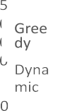

The rate of increase of the memory utilization with the increase in the number of items is linear for all the three techniques, as shown in Graph. 3.

### Graph.4

.

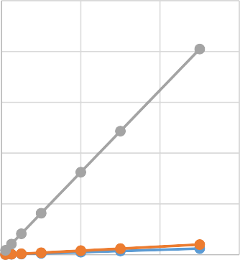



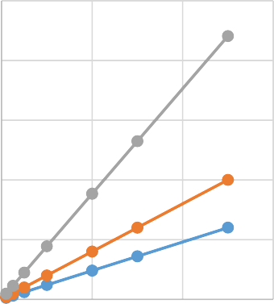

# 4 Conclusion

In conclusion, the Knapsack Problem exemplifies the delicate balance between theoretical complexity and practical relevance in the realm of combinatorial optimization. As researchers and practitioners continue to push the boundaries of this problem, the significance of its contributions to decision-making and resource allocation will only grow, making it an enduring and essential topic in the field of operations research and mathematics.

REFERENCES

1. Levitin, Anany. The Design and Analysis of Algorithms. New Jersey: Pearson Education Inc., 2003.
2. Knapsack problem- Wikipedia, the free encyclopedia. https://en.wikipedia.org/wiki/Knapsack_problem.
3. Hristakeva, Maya and DiptiSrestha. “Different Approaches to Solve the 0/1 Knapsack Problem”, MICS 2005 proceedings**.**[www.micsymposium.org/mics_2005/papers/](http://www.micsymposium.org/mics_2005/papers/) paper102.pdf.
4. Martello, Silvano; Toth, Paolo (1990). Knapsack problems: Algorithms and computer interpretations. Wiley-Interscience.
5. Gossett, Eric. Discreet Mathematics with Proof. New Jersey: Pearson Education Inc., 2003.
6. 0/1KNAPSACKPROBLEM[http://www.swatijain.tripod.c](http://www.swatijain.tripod.c/) om/knapsack2.htm

Make sure to remove all placeholder and explanatory